18 - FOOD ORDERING SYSTEM

USE CASE DIAGRAM:

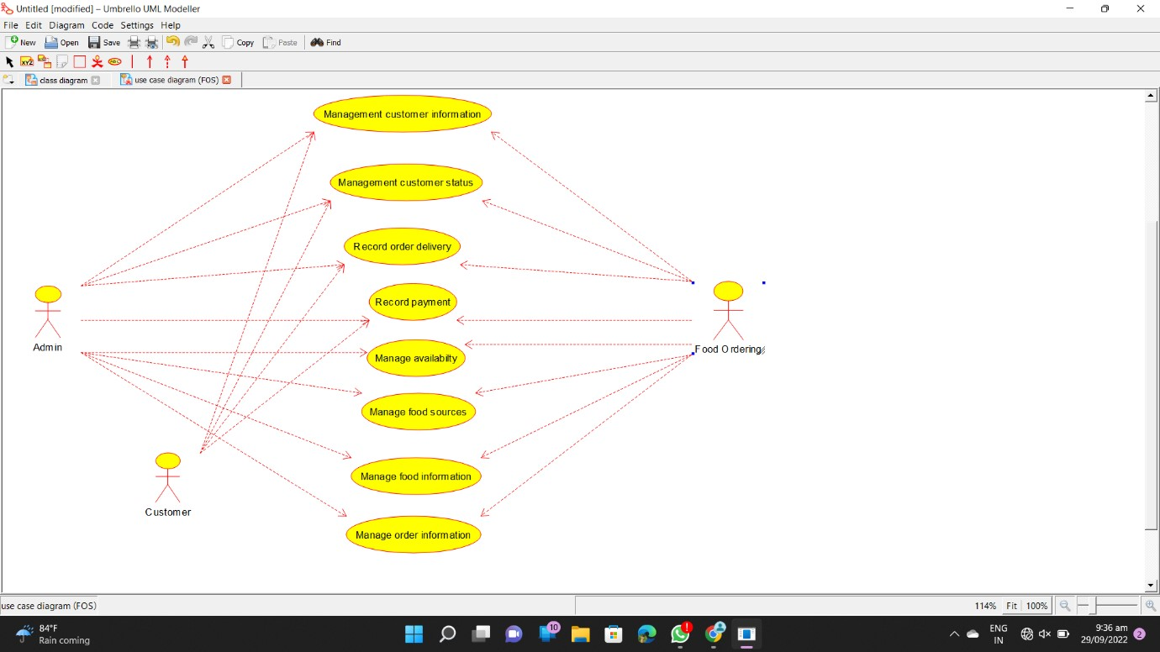

CLASS DIAGRAM:

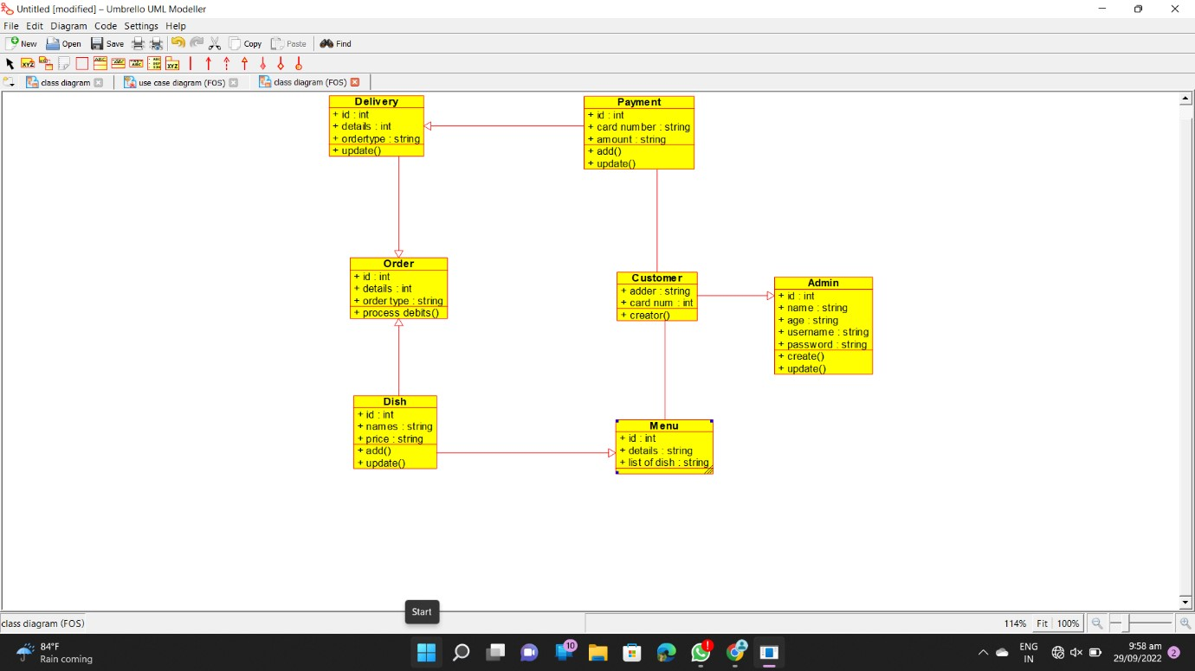

ACTIVITY DIAGRAM:

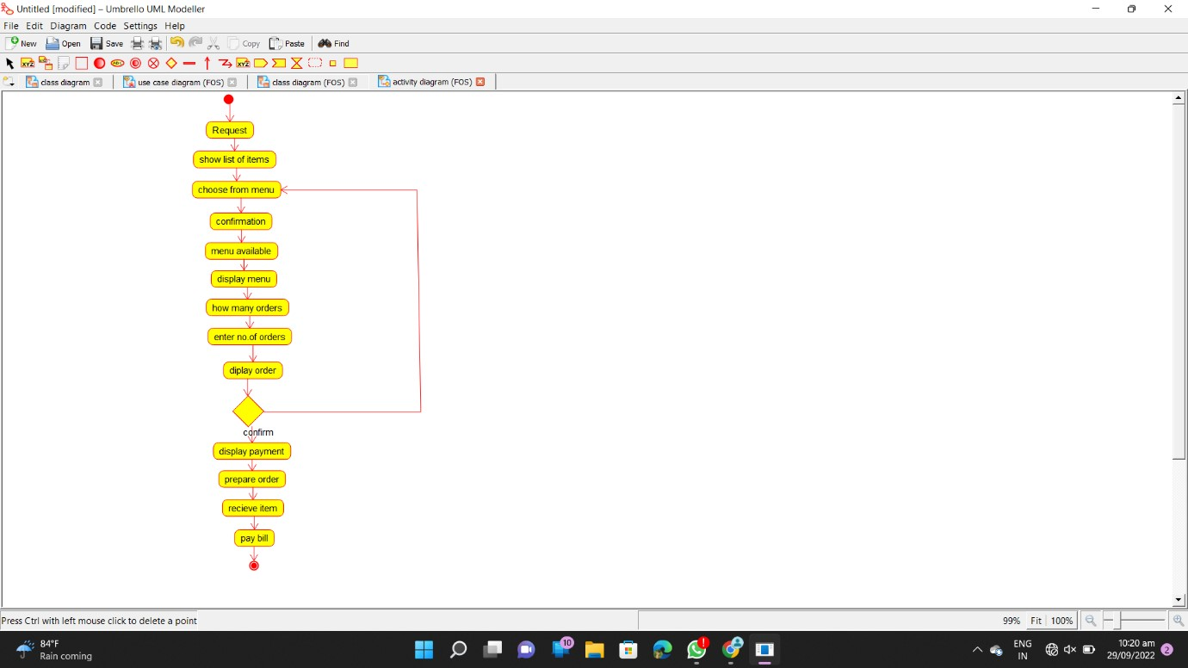

SEQUENCE DIAGRAM:

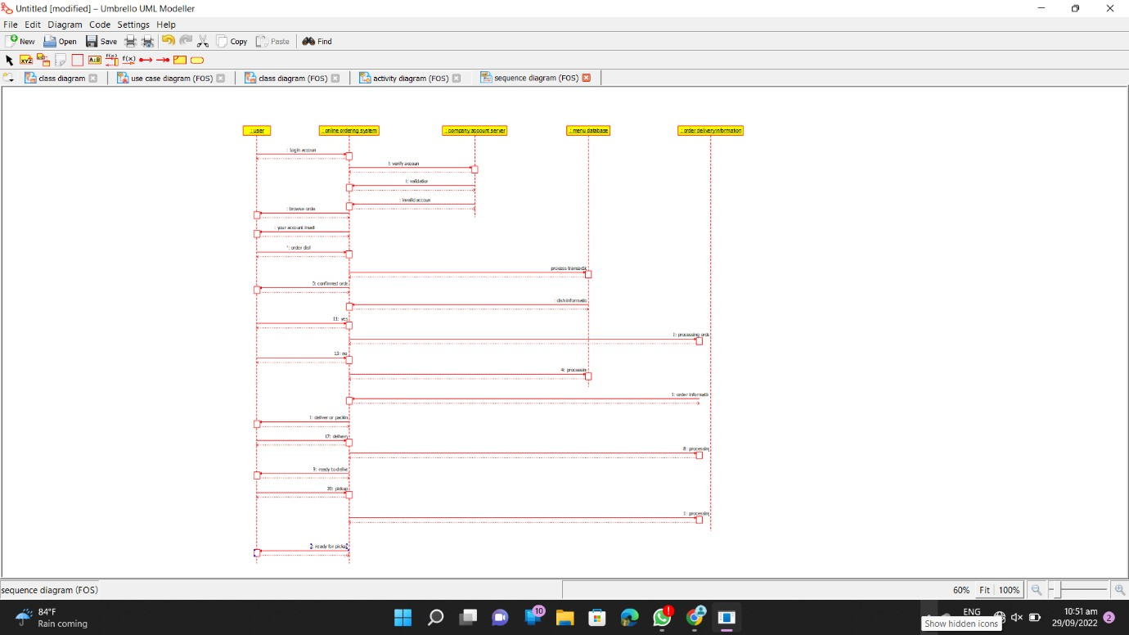

COLLABORATION DIAGRAM:

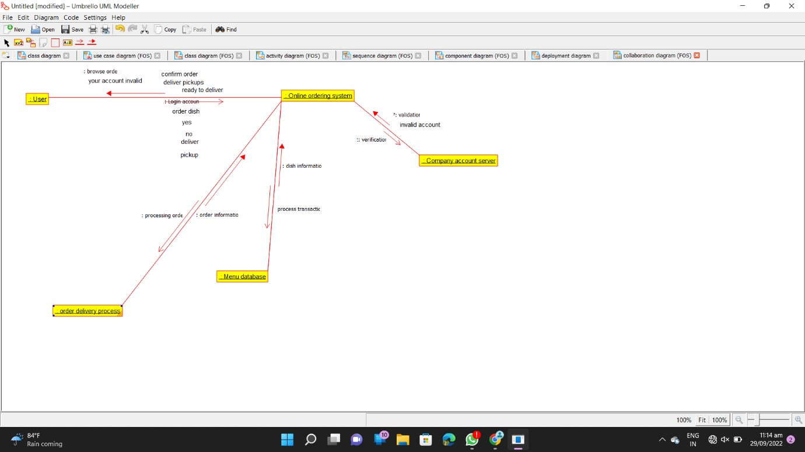

COMPONENT DIAGRAM:

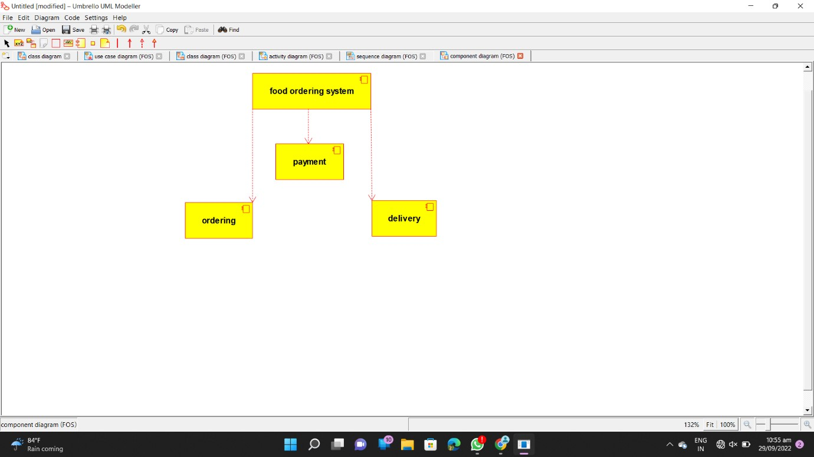

**CODE :**

/**

* Class Admin

*/

public class Admin {

//

// Fields

//

public int id; public String name; public String age; public String username; public String password;

//

// Constructors

//

public Admin () { };

//

// Methods

//

//

// Accessor methods

//

/**

* Set the value of id
* @param newVar the new value of id

*/

public void setId (int newVar) { id = newVar;

}

/**

* Get the value of id
* @return the value of id

*/ public int getId () { return id;

}

/**

* Set the value of name
* @param newVar the new value of name

*/

public void setName (String newVar) { name = newVar;

}

/**

* Get the value of name
* @return the value of name

*/

public String getName () { return name;

}

/**

* Set the value of age
* @param newVar the new value of age

*/

public void setAge (String newVar) { age = newVar;

}

/**

* Get the value of age
* @return the value of age

*/

public String getAge () { return age;

}

/**

* Set the value of username
* @param newVar the new value of username

*/ public void setUsername (String newVar) { username = newVar;

}

/**

* Get the value of username
* @return the value of username

*/

public String getUsername () { return username;

}

/**

* Set the value of password
* @param newVar the new value of password

*/

public void setPassword (String newVar) { password = newVar;

}

/**

* Get the value of password
* @return the value of password

*/

public String getPassword () { return password;

}

//

// Other methods

//

*/ public void create()

{

}

/**

*/

public void update()

{

}

}

import java.util.*; /**

* Class Customer

*/

public class Customer extends Admin {

//

// Fields

//

public String adder; public int card_num;

//

// Constructors

//

public Customer () { };

//

// Methods

//

//

// Accessor methods

//

/**

* Set the value of adder
* @param newVar the new value of adder

*/

public void setAdder (String newVar) { adder = newVar;

}

/**

* Get the value of adder
* @return the value of adder

*/

public String getAdder () { return adder;

}

/**

* Set the value of card_num
* @param newVar the new value of card_num

*/

public void setCard_num (int newVar) { card_num = newVar;

}

* Get the value of card_num
* @return the value of card_num

*/

public int getCard_num () { return card_num;

}

//

// Other methods

//

/**

*/

public void creator()

{

}

}

/**

* Class Delivery

*/ public class Delivery extends Order {

//

// Fields

//

public int id;

public int details;

public String ordertype;

//

// Constructors

//

public Delivery () { };

//

// Methods

//

//

// Accessor methods

//

/**

* Set the value of id
* @param newVar the new value of id

*/

public void setId (int newVar) { id = newVar;

}

/**

* Get the value of id
* @return the value of id

*/ public int getId () { return id;

}

* Set the value of details
* @param newVar the new value of details

*/

public void setDetails (int newVar) { details = newVar;

}

/**

* Get the value of details
* @return the value of details

*/ public int getDetails () { return details;

}

/**

* Set the value of ordertype
* @param newVar the new value of ordertype

*/

public void setOrdertype (String newVar) { ordertype = newVar;

}

/**

* Get the value of ordertype
* @return the value of ordertype

*/

public String getOrdertype () { return ordertype;

}

//

// Other methods

//

/**

*/

public void update()

{

}

}

/**

* Class Dish

*/

public class Dish extends Order, Menu {

//

// Fields

//

public int id; public String names; public String price;

//

// Constructors

//

public Dish () { };

//

// Methods

//

//

// Accessor methods

//

/**

* Set the value of id
* @param newVar the new value of id

*/

public void setId (int newVar) { id = newVar;

}

/**

* Get the value of id
* @return the value of id

*/ public int getId () { return id;

}

/**

* Set the value of names
* @param newVar the new value of names

*/

public void setNames (String newVar) { names = newVar;

}

/**

* Get the value of names
* @return the value of names

*/ public String getNames () {

return names;

}

/**

* Set the value of price
* @param newVar the new value of price

*/

public void setPrice (String newVar) { price = newVar;

}

/**

* Get the value of price
* @return the value of price

*/ public String getPrice () { return price;

}

//

// Other methods

//

/**

*/

public void add()

{

}

/**

*/

public void update()

{

} } import java.util.*; /**

* Class Menu

*/

public class Menu {

//

// Fields

//

public int id; public String details; public String list_of_dish;

//

// Constructors

//

public Menu () { };

//

// Methods

//

//

// Accessor methods

//

/**

* Set the value of id
* @param newVar the new value of id

*/

public void setId (int newVar) { id = newVar;

}

/**

* Get the value of id
* @return the value of id

*/ public int getId () { return id;

}

/**

* Set the value of details
* @param newVar the new value of details

*/

public void setDetails (String newVar) { details = newVar;

}

/**

* Get the value of details
* @return the value of details

*/ public String getDetails () { return details;

}

/**

* Set the value of list_of_dish
* @param newVar the new value of list_of_dish

*/

public void setList_of_dish (String newVar) { list_of_dish = newVar;

}

/**

* Get the value of list_of_dish
* @return the value of list_of_dish

*/

public String getList_of_dish () { return list_of_dish;

}

//

// Other methods

//

}

/**

* Class Order

*/ public class Order {

//

// Fields

//

public int id;

public int details; public String order_type;

//

// Constructors

//

public Order () { };

//

// Methods

//

//

// Accessor methods

//

/**

* Set the value of id
* @param newVar the new value of id

*/

public void setId (int newVar) { id = newVar;

}

/**

* Get the value of id
* @return the value of id

*/ public int getId () { return id;

}

/**

* Set the value of details
* @param newVar the new value of details

*/

public void setDetails (int newVar) { details = newVar;

}

/**

* Get the value of details
* @return the value of details

*/ public int getDetails () { return details;

}

/**

* Set the value of order_type
* @param newVar the new value of order_type

*/

public void setOrder_type (String newVar) { order_type = newVar;

}

/**

* Get the value of order_type
* @return the value of order_type

*/

public String getOrder_type () { return order_type;

}

//

// Other methods

//

/**

*/

public void process_debits()

{

} } import java.util.*; /**

* Class Payment

*/

public class Payment extends Delivery {

//

// Fields

//

public int id; public String card_number; public String amount;

//

// Constructors

//

public Payment () { };

//

// Methods

//

//

// Accessor methods

//

/**

* Set the value of id
* @param newVar the new value of id

*/

public void setId (int newVar) { id = newVar;

}

/**

* Get the value of id
* @return the value of id

*/ public int getId () { return id;

}

/**

* Set the value of card_number
* @param newVar the new value of card_number

*/

public void setCard_number (String newVar) { card_number = newVar;

}

/**

* Get the value of card_number
* @return the value of card_number

*/

public String getCard_number () { return card_number;

}

/**

* Set the value of amount
* @param newVar the new value of amount

*/

public void setAmount (String newVar) { amount = newVar;

}

/**

* Get the value of amount
* @return the value of amount

*/

public String getAmount () { return amount;

}

//

// Other methods

//

/**

*/

public void add()

{

}

/**

*/

public void update()

{

}

}